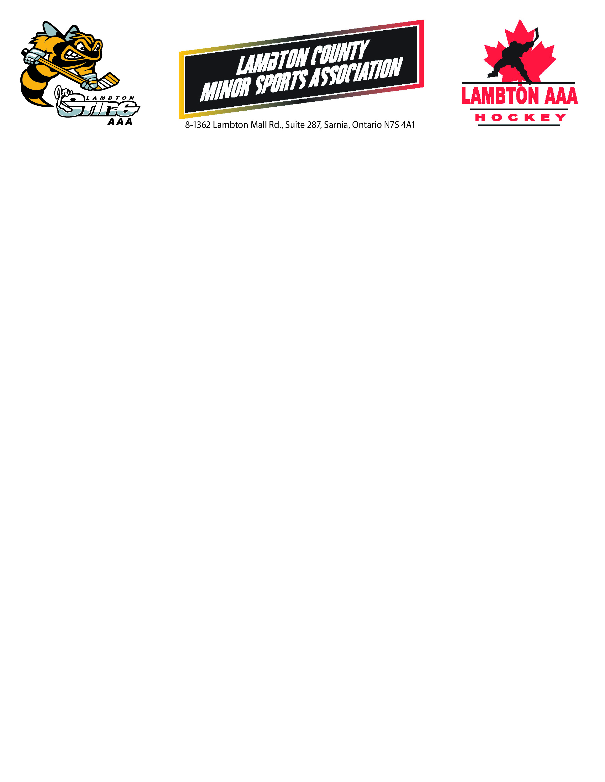

**Sweater Sponsors**

### $200 (sponsor bars will be on both home and away jerseys)

* A team can have one sponsor for all jerseys
* All sponsors must meet the Lambton Jr Sting AAA Association and Sarnia Sting criteria
* The jerseys remain the possession of the Lambton Jr Sting AAA Association and are to be returned at the end of the season in good condition.
* The cost to produce, affix and remove the sponsor bars will be paid for by the Lambton Jr Sting Association
* Players can obtain two different sponsors for each of Home and Away if desired ($100 each)

# Sweater Sponsor Criteria

### Sponsors must be a bonafide company and not a family member or friend

1. **There cannot be individual names on the jerseys with the exception of sponsors such as John Smith Accountant, June Smith Investment Consultant, etc**
2. **The sponsor shall uphold the standards of the Lambton Jr Sting Association**
3. **Unacceptable sponsors include but are not limited to businesses that are associated with alcohol (including bars but not including restaurants), tobacco, internet websites dealing in inappropriate behaviour, dating services**
4. **The Lambton Jr Sting AAA Association and the Sarnia Sting Association reserve the right to decline sponsors**
5. **All jersey sponsors will receive a receipt from the Lambton Jr Sting AAA Association for their contribution upon approval**

**Sweater Sponsor Timelines**

* Team Managers are to provide the names of the players, their chosen number and the sponsor for each jersey to the Lambton Jr Sting AAA Association by August Sponsor cheques must be accompanied by the Sweater Sponsor Application
* All sponsor cheques
* Team Managers will be advised of the approval of sponsors by August 10 via email
* If all above conditions are met, the Association will have all sponsor bars affixed and jerseys to team managers by Sept 1.